Board assurance statement

Our Board takes its obligations for good corporate governance extremely seriously and dedicates time and expertise to ensure that the Board as a whole is able to fulfill its responsibilities. This submission has been prepared under the assurance processes applicable to all our regulatory submissions and performance reports. The Company’s track record of performance reporting is strong and has been recognised as compliant with Ofwat’s reporting requirements under the Company Monitoring Framework for both years upon which assessments have been carried out and reports issued.
The significance the Board has attached to good governance of this Business Plan submission is emphasised by devoting chapters of our 200-page main submission to governance and to assurance, where we describe in detail the approach we have taken. This assurance summary statement relies upon, and should be read in conjunction with, the detail provided there.

Our plan for 2020 to 2025 is firmly anchored in a much longer-term perspective. We have published a Long-Term Vision and have planned operational, financial and corporate resilience for the long-term. Our revised draft Water Resources Management Plan covers 60 years and our targets for leakage, bursts and supply interruptions cover multiple regulatory periods. We have stress tested our financial resilience to 2030.

Our plan is based upon a firm understanding of our customers’ priorities, obtained through our close, regular dialogue with the communities we serve and through the deployment of best in class survey and engagement techniques. Our Customer Scrutiny Panel has had full transparency of the way in which customers’ views have been reflected in our plan and has challenged us appropriately.

We have developed our plan in the context of the Government’s Strategic Policy Statement and its 25-Year Environment Plan alongside the guidance issued by the Environment Agency and the Drinking Water Inspectorate. We have worked with other regulators and stakeholders to produce a plan that delivers benefits to our local environment and society at large, as well as meeting our statutory and regulatory obligations.

The whole Board has played a full part in the development of our plan. Our independent non-executive directors have acted as champions for the key themes of great customer service, affordability, resilience and innovation, and have attended workshops and meetings of our Customer Scrutiny Panel to contribute to debates. They have also chaired Board committees, established to focus on aspects of our plan, including strategy for financing, governance, pensions and energy and carbon management. The whole Board has considered reports on progress at each meeting and has dedicated special meetings to consideration of strategic aspects of our plan.

Our assurance process is designed to ensure that our Business Plan accords with Ofwat’s methodology and the requirements of our stakeholders and customers. The Board has held the management team to account and challenged and tested the proposals within our plan. We have tested our submission against the criteria Ofwat will use for their Initial Assessment of Plans and consider that it meets the criteria for a high quality, innovative and deliverable plan. We have used internal reviews and appropriately qualified independent third-party assurance providers to test the reasonableness and reliability of our plans.

Historic performance data and forecasts have been assembled under well-established procedures used to compile our annual performance reports. Data is collated and checked by senior managers, and all tables and commentaries are owned and reviewed by the relevant executive director. The same approach has been adopted for forecasts. The Company is ISO9001 accredited and the Company’s systems and procedures are regularly checked and audited by internal and external auditors.

Assurance statements

The Board confirms that:

- We consider that all the elements of our PR19 Business Plan submission add up to a high quality plan that is deliverable with the resources proposed
- We have challenged management on a regular basis, and using our knowledge of past performance and future plans, have satisfied ourselves that plans are stretching but realistic
- We are satisfied that our plan will deliver operational, financial and corporate resilience to at least 2030
- Our plan will deliver outcomes that are consistent with our legal obligations, the Government’s strategic policy statements and regulatory guidance
- Our plan will underpin a continued level of trust and confidence from the communities we serve, through promoting transparency and engagement on issues that matter to them.

We confirm that, at its meeting on 20 August 2018, the full Board reviewed the Company’s PR19 Business Plan and approved its submission to Ofwat. We consider that the plan in the round proposes a package that meets our customers’ expectations and will be well received by them.

Signed by:

Jeremy Pelczer, Chairman | 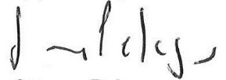
Murray Legg, Senior Independent Non-executive | 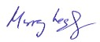
Dave Shemmans, Independent Non-executive | 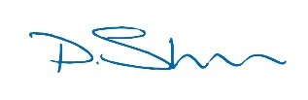
Jon Woods, Independent Non-executive | 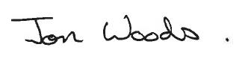
Yoichi Sakai, Shareholder Nominated Non-executive | 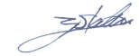
Ryuichi Nishida, Shareholder Nominated Non-executive | 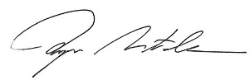
Anthony Ferrar, Managing Director | 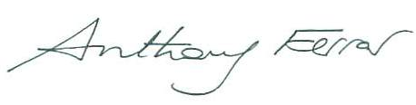
Paul Kerr, Finance and Regulation Director | 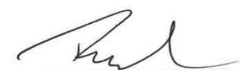
John Chadwick, Regulation Director | 